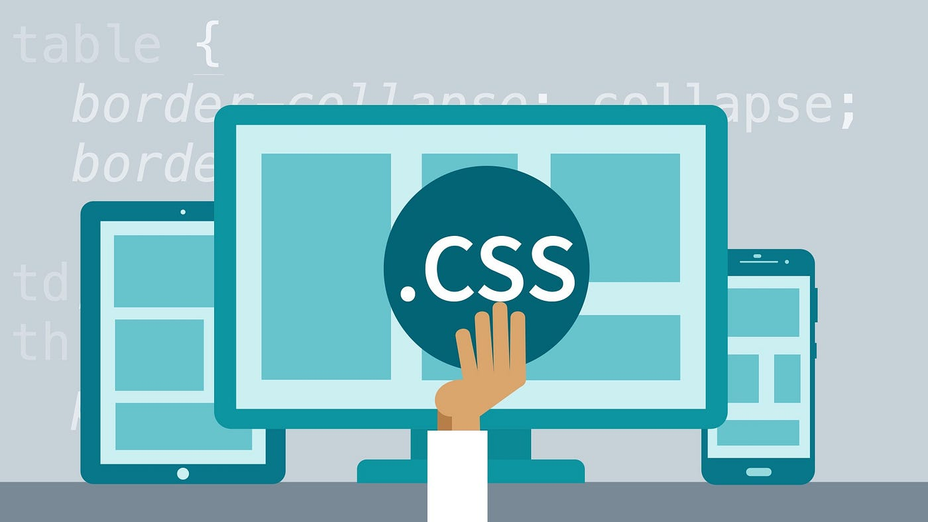 | Abstract  This module introduces CSS, its types (inline, internal, external), and selectors with specificity. It covers key properties for backgrounds, text, fonts, borders, and the box model. Learners also explore layout techniques using display, flexbox, grid, and positioning for effective web page design.
  Introduction to CSS

Unit-4 Introduction to CSS

Significance of CSS
CSS stands for Cascading Style Sheet.

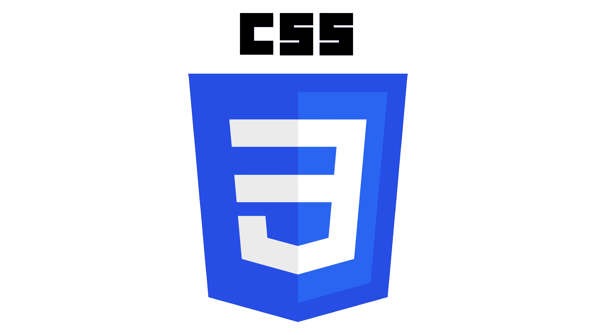

- CSS is a style sheet language used to control the presentation (look and layout) of web pages written in HTML.
- It defines how elements should be displayed, including colors, fonts, spacing, and overall layout.
- Without CSS, web pages use the browser’s default styles, resulting in a plain and basic appearance.

- CSS allows developers to:
  - Create visually appealing, consistent web pages.
  - Maintain separation of content (HTML) and presentation (CSS) for better organization.
  - Reuse the same stylesheet across multiple web pages, saving time and effort.
  - Enhance accessibility and improve user experience across devices and screen sizes.

Initially, without adding a CSS, What you are seeing are the browser's default styles, very basic styles that the browser applies to HTML to make sure that the page will be basically readable even if no explicit styling is specified by the author of the page.
The web would be a boring place if all websites looked like that. Using CSS, you can control exactly how HTML elements look in the browser, presenting your markup using whatever design you like.

How CSS works with HTML?
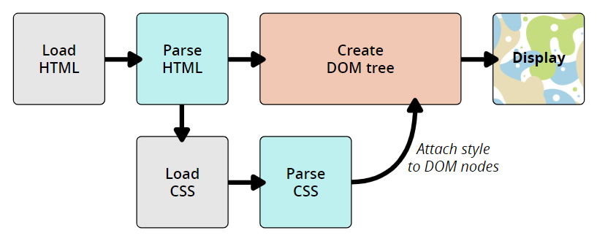

How CSS Works
- Load HTML – The browser first loads the web page’s structure, which contains all the text, headings, and images.
- Parse HTML – It then reads and understands the HTML elements on the page (like titles, paragraphs, etc.).
- Create DOM Tree – The browser builds a map (a tree-like structure) showing how all the elements are connected.
- Load and Parse CSS – Next, the browser loads the CSS file and reads the styles , such as colors, fonts, and layouts.
- Attach Styles to HTML Elements – The browser matches each style rule to the right HTML elements in the DOM.
- Display the Page – Finally, the browser combines the structure (HTML) and the style (CSS) and shows the beautifully designed page on your screen.
Imagine opening a recipe website:
- HTML gives you the content — the title, ingredients, and steps.
- CSS makes it look nice — colorful headings, clean layout, and easy-to-read text.
- The browser mixes both together and displays a clear, well-styled recipe page for you.

Structure or Syntax of CSS
- The syntax of CSS is slightly different from that of an HTML.
- CSS uses (curly braces { } ), (colons : ) and (semicolon ; ).
Syntax:
selector
{
property : value;
property : value;
| |
property : value;
}
- selector: Specifies which HTML element(s) to style (e.g., tag(element), id, class, etc.).
- property: The aspect of the element you want to change (e.g., color, font-size).
- value: The specific setting for that property.
Example:
p {
color: blue;
text-align: center;
}
- p is a selector(element). It styles all the <p> element of the document with color blue and aligned the content in the center of the screen.
- color and text-align are properties, and blue and center are the respective property values.

Types of CSS

Type of CSS | Description | Where It Is Written | Syntax (Example)
1. Inline CSS | Used to style a single HTML element directly. It has the highest priority. | Inside the HTML tag using the style attribute. | <h1 style="color:blue; font-size:25px;">Heading</h1>
2. Internal (Embedded) CSS | Used to style elements within the same HTML page. | Inside the <style> tag in the <head> section of the HTML document. | <head><style> p { color: red; font-size: 18px; } </style></head>
3. External CSS | Used to apply styles to multiple web pages using a separate .css file. | In an external stylesheet linked using the <link> tag in the <head> section. | <head><link rel="stylesheet" href="style.css"></head>(style.css file contains CSS rules)

1) Inline CSS
- Used to apply a unique style to a single HTML element.
- Uses the style attribute inside the element tag.
Syntax:
<element style="property:value; property:value;"></element>
Example:
<h1 style="color:green; font-size:30px;">A Green Heading</h1>
Explanation:
- The text color of the <h1> element is set to green and the font size to 30px.
- Inline CSS has the highest priority among all CSS types.

2) Internal (Embedded) CSS
- Used to define styles for a single HTML page.
- Written inside the <style> tag within the <head> section of the page.
Syntax:
<head>
<style>
selector {
property-name1: value;
property-name2: value;
}
</style>
</head>

Example:
<head>
<style>
body { background-color: pink; }
h1 { color: blue; }
p { color: purple; font-size: 18px; }
</style>
</head>
Explanation:
- The background color of the page becomes pink.
- All headings (<h1>) are blue.
- Paragraphs (<p>) are purple with font size 18px.

3) External CSS
- Styles are written in a separate .css file.
- The CSS file is linked to the HTML page using the <link> tag inside the <head> section.
- It helps keep HTML clean and allows styles to be reused across multiple pages.
Example
(HTML file):
<head>
<link rel="stylesheet" href="style.css">
</head>
<body>
<h1>This is a heading</h1>
<p>This is a paragraph.</p>
</body>

(style.css file):
body { background-color: pink; }
h1 { color: blue; }
p { color: purple; font-size: 18px; }

Why Use External CSS
- Keeps design and content separate for better structure.
- Allows reusability, one CSS file can style multiple pages.
- Simplifies maintenance, change one file to update the entire website.
- Ensures consistent design across all web pages.

Various CSS Selectors

A CSS selector is used to target HTML elements so you can apply styles to them.
- Select elements to style.
- Apply styles efficiently to many elements at once.
- Control which styles take priority (specificity).
- Enable dynamic effects with pseudo-classes/elements.
Selector Type | Description | Syntax | Example
Element Selector | Selects all elements of a specific type/tag. Lowest specificity (except universal). | element | p { color: black; }
ID Selector | Selects a single element with a specific id attribute. Very high specificity. | #id | #header { color: red; }
Class Selector | Selects elements with a specific class. Medium specificity. | .class | .menu { font-size: 16px; }
Attribute Selector | Selects elements based on an attribute or attribute value. | [attr], [attr=value] | [type="text"] { border: 1px solid #ccc; }
Universal Selector | Selects all elements. Lowest specificity. | * | * { margin: 0; padding: 0; }
Descendant Selector | Selects elements that are descendants (any level) of a specified ancestor. | ancestor descendant | div p { color: blue; }
Child Selector | Selects elements that are direct children of a specified parent. | parent > child | ul > li { list-style: none; }
Grouping Selector | Groups multiple selectors and applies the same styles. | selector1, selector2 | h1, h2, h3 { font-family: Arial; }

- Element Selector

Syntax:
element-name { property: value; property: value; }
Example:

Here, all <p> elements on the page will be center-aligned, with a red text color:

<html>
<head>
<style>
p {
text-align: center;
color: red;
}
</style>
</head>
<body>
<p>Test<p>
<p>Hello!</p>
</body>
</html>

Output:

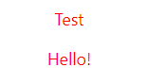

- CSS ID Selector
- The id selector uses the id attribute of an HTML element to select a specific element.
- The id of an element is unique within a page, so the id selector is used to select one unique element!
- To select an element with a specific id, write a hash (#) character, followed by the id of the element.

Note: id attribute must begin with a letter and is case sensitive

Synatx:
#element-id{ property1: value; property2: value; }

Example:
<html>
<head>
<style>
#para1 {
text-align: center;
color: red;
}
</style>
</head>
<body>
<p id="para1">Paragraph with ID</p>
<p>Paragraph without ID</p>
</body>
</html>

Output:

- CSS Class Selector
- The class selector selects HTML elements with a specific class attribute.
- To select elements with a specific class, write a period (.) character, followed by the class name.

Syntax:
.element-classname { property: value; }

Example1:
<html>
<head>
<style>
.center{
text-align: center;
color: red;
}
</style>
</head>
<body>
<h1 class="center">H1 tag using class selector</h1>
<p class="center">P tag using class selector</p>
</body>
</html>

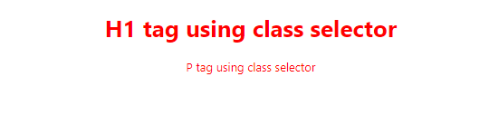

Example 2:
- You can also specify that only specific HTML elements should be affected by a class.
- In this example only <p> elements with class="center" will be affected.

<html>
<head>
<style>
p.center {
text-align: center;
color: red;
}
</style>
</head>
<body>
<h1 class="center">No effect of center class</h1>
<p class="center">Red and Center aligned</p>
<p>No effect of center class </p>
</body>
</html>

Output:


Example 3:
- HTML elements can also refer to more than one class.
- In this example the <p> element will be styled according to class="center" and to class="large":

<head>
<style>
.center {
text-align: center;
color: red;
}
.large {
font-size: 50px;
}
</style>
</head>
<body>
<h1 class="center">No effect of center class</h1>
<p class="center large">Effect of both center and large class</p>
</body>

Output:
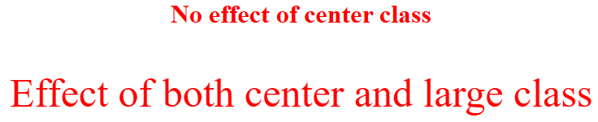

- Universal Selector

- The universal selector (*) selects all HTML elements on the page.
Syntax:
* { property: value; }
Example:
- The CSS rule below will affect every HTML element on the page:

<html>
<head>
<style>
* {
text-align: center;
color: blue;
}
</style>
</head>
<body>
<h1>Universal Selector</h1>
<p>Using this</p>
<pre>Every element on the page will be affected by the style.</pre>
</body>
</html>

Output:
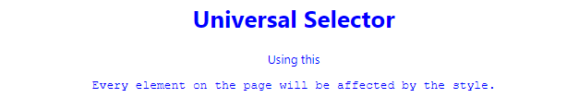

By adding a css to particular element as shown below. It will override the color of p element(s).

<style>
* {
text-align: center;
color: blue;
}
p{
color: red;
}
</style>

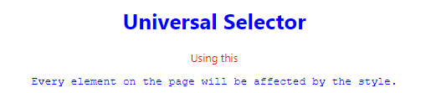

- Attribute selector:
- It is possible to style HTML elements that have specific attributes or attribute values.
- The [attribute] selector is used to select elements with a specified attribute.
- The attribute selectors can be useful for styling forms or any other elements using their attribute.
Syntax:
element-name[type=”text”]
{
property: value;
}

Example:

<head>
<style>
input[type=text] {
width: 300px;
margin-bottom: 10px;
background-color: lightpink;
color:rgb(125, 73, 247);
padding:10px;
margin: 10px;
}
input[type=button] {
margin:30px;
background-color: yellow;
padding:20px 30px;
font-size:20px;
}
a[target=_blank] {
color: blueviolet;
font-size: x-large;
text-decoration: none;
text-transform: uppercase;
}
</style>
</head>

<body>
<form name="input" action="" method="get">
Firstname:<input type="text" name="Name"> <br>
Email:<input type="email" name="Name"><br>
<input type="button" value="Submit">
</form>
<a href="#" target="_blank">Link 1</a>
<a href="#">Link 2</a>
</body>

Output:

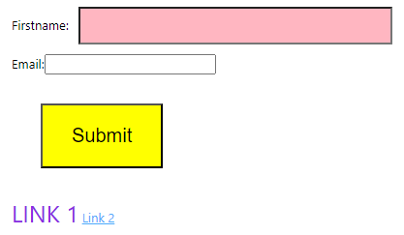

CSS Combinators
- A combinator is something that explains the relationship between the selectors.
- A CSS selector can contain more than one simple selector. Between the simple selectors, we can include a combinator.

Combinators in CSS:
- descendant selector (space)
- child selector (>)

- Descendant Selector
- If some tag is nested in the other tag then nested tag is called as descendant of parent tag.
- The Descendant Selectors can be any selector having the white-space in between the elements without using any combinators. Descendant is a manner to nested anywhere within the DOM tree. This selector is used to select all the child elements of the specified tag.

Syntax:
element1 element2
{
property: value;
}

Example 1:
<head>
<style>
.d1 p {
background-color: yellow;
}
</style>
</head>
<body>
<h2>The descendant selector matches all elements that are descendants of a specified element.</h2>
<div>
<p>Paragraph 1 in the div.</p>
<section><p>Paragraph 2 in the div.</p></section>
</div>
<div class="d1"><p>Paragraph 3. is in a div with class d1</p></div>

Output:
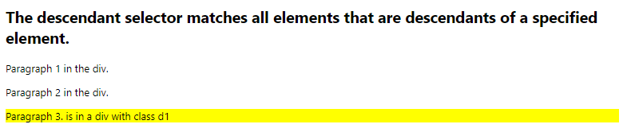
Example 2:
<head>
<style>
div.d1 p {
background-color: lightblue;
}
</style>
</head>
<body>
<div class="d1">
<p>Paragraph 1 in the div.</p>
<section>
<p>Paragraph 2 in the div.</p>
</section>
<p>Paragraph 3 in the div.</p>
</div>

<p>Paragraph 4 After a div.</p>
</body>

Output:
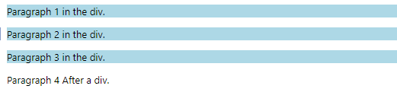

It applies background color to the all nested p elements of the div element. (child, grandchild, great grandchild …..)

- Child Selector >
- The child selector selects all elements that are the children of a specified element.
- To apply CSS, nested tag must be a direct child of previous tag.
- The following example selects all <p> elements that are children of a <div> element:

Syntax:
element1 > element2
{
property:value;
}
Example 1:
<head>
<style>
div.d1>p {
background-color: lightblue;
}
</style>
</head>
<body>

<div class="d1">
<p>Paragraph 1 in the div.</p>
<section>
<p>Paragraph 2 in the div.</p>
</section>
<p>Paragraph 3 in the div.</p>
</div>

<p>Paragraph 4 After a div.</p>
</body>
Output:
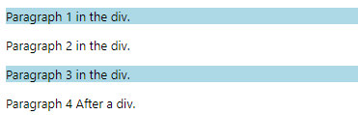
- It applies background color to only direct child p element/s of div element.
- Grandchild , great grandchild etc will not get affected in child selector.

- Grouping Selector
The Grouping Selector allows you to apply the same style to multiple elements at once, saving time and reducing repetition in your CSS.
Syntax:
selector1, selector2, selector3 {
property: value;
}

Example:
h1, h2, h3 {
font-family: Arial, sans-serif;
color: darkblue;
}
- This rule applies the same font and color to all <h1>, <h2>, and <h3> elements.

Example:
Write CSS to perform the tasks as asked below.
  - Add unordered list with 3 list items.
  - If direct child of the ul element is <b> then apply font color blue and font size should be 20px.
  - If direct child of the ul element is <li> then item should be displayed in red color and in smaller font size.
<head>
<style>
ul>b {
font-size:20px;
color:blue;
}
ul>li {
font-size:smaller;
color:rgb(255, 0, 43);
}
</style>
</head>
<body>
<ul> <li><b>abc</b></li>
<li><b>xyz</b></li>
<b><li>pqr</li></b>
</ul>
</body>
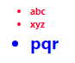

CSS Specificity (Priority Order)
When multiple CSS rules target the same element, the browser decides which one to apply based on specificity (priority):
Priority Level | Selector Type | Example
1 (Highest) | Inline Styles | <h1 style="color:pink;">Heading</h1>
2 | IDs | #title { color: red; }
3 | Classes, pseudo-classes, attribute selectors | .title { color: green; }, :hover, [type='text']
4 (Lowest) | Elements and pseudo-elements | h1 { color: blue; }, ::before
<head>
<style>
h1 { color: blue; } /* Element selector */
.main { color: green; } /* Class selector */
#title { color: red; } /* ID selector */
</style>
</head>
<h1 id="title" class="main" style="color:pink;">Welcome!</h1>

Rule Type | Color | Priority Level | Who Wins?
h1 { color: blue; } | Blue | Lowest (Element) | ❌ Overridden
.main { color: green; } | Green | Medium (Class) | ❌ Overridden
#title { color: red; } | Red | High (ID) | ❌ Overridden
style="color:pink;" | Pink | Highest (Inline) | ✅ Applied

Text Properties
These properties are used to style, format, and control the appearance of text on a webpage, including alignment, spacing, transformation, decoration, font type, and size.

Text Properties
Property | Description | Syntax | Possible Values
color | Sets the color of the text | color: color; | Named colors (e.g., red), HEX (#ff0000), RGB (rgb(255,0,0)), RGBA, HSL, HSLA
text-align | Aligns text inside an element | text-align: value; | left, right, center, justify, start, end
text-indent | Adds indentation to the first line | text-indent: length; | Any length (px, em, %)
text-transform | Controls text capitalization | text-transform: value; | none, capitalize, uppercase, lowercase
text-decoration | Adds decoration like underline or line-through | text-decoration: value; | none, underline, overline, line-through, underline overline
letter-spacing | Controls space between letters | letter-spacing: length; | Normal (normal), or custom spacing (px, em)
word-spacing | Controls space between words | word-spacing: length; | Normal (normal), or custom spacing (px, em)
line-height | Sets space between lines | line-height: value; | normal, number (e.g., 1.5), length (px, em), %
text-shadow | Adds shadow to text | text-shadow: h-shadow v-shadow blur color; | none or values like 2px 2px 5px gray (can add multiple shadows separated by commas)
Example:
<head>
<title>CSS Text Properties Example</title>
<style>
body {
font-family: Arial, sans-serif;
padding: 20px;
line-height: 1.6;
}

/* Underline text */
.underline {
text-decoration: underline;
color: blue;
text-align: left;
text-transform: capitalize;
text-indent: 30px;
letter-spacing: 2px;
word-spacing: 5px;
text-shadow: 2px 2px 3px gray;
}

/* Overline text */
.overline {
text-decoration: overline;
color: green;
text-align: center;
text-transform: uppercase;
text-indent: 0px;
letter-spacing: 1px;
word-spacing: 3px;
text-shadow: 1px 1px 2px black;
}

/* Line-through text */
.line-through {
text-decoration: line-through;
color: red;
text-align: right;
text-transform: lowercase;
text-indent: 0px;
letter-spacing: 1px;
word-spacing: 2px;
text-shadow: 1px 1px 3px gray;
}

/* Combined text-decoration */
.combined {
text-decoration: underline overline;
color: purple;
text-align: justify;
text-transform: capitalize;
text-indent: 40px;
letter-spacing: 3px;
word-spacing: 6px;
text-shadow: 3px 3px 5px gray;
}
</style>
</head>
<body>

<h2>CSS Text Properties Demo</h2>
<p class="underline">
This text demonstrates <b>underline</b> with all other text properties applied.
</p>

<p class="overline">
This text demonstrates <b>overline</b> with all other text properties applied.
</p>
<p class="line-through">
This text demonstrates <b>line-through</b> with all other text properties applied.
</p>
<p class="combined">
This text demonstrates <b>combined underline + overline</b> with all other text properties applied.
</p>
</body>
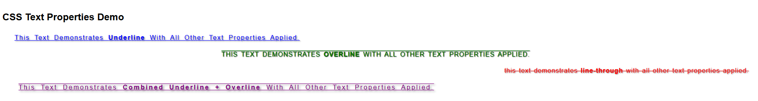
- .underline → blue, left-aligned, capitalized, indented, spaced letters/words, with shadow.
- .overline → green, centered, uppercase, spaced letters/words, with shadow.
- .line-through → red, right-aligned, lowercase, spaced letters/words, with shadow.
- .combined → purple, justified, capitalized, combined underline + overline, letter & word spacing, shadow.
Note:
Use left / right if your site is single-language and fixed layout.
Use start / end for multilingual, adaptive layouts — it ensures your design works for LTR and RTL automatically.

Font Properties

Property | Description | Syntax | Example | Possible Values
font-family | Specifies the font type | font-family: "FontName", fallback; | font-family: "Arial", sans-serif; | Any font name: "Arial", "Times New Roman", "Courier New", generic families: serif, sans-serif, monospace, cursive, fantasy
font-size | Sets the font size | font-size: size; | font-size: 20px; | Length units: px, em, rem, %; Keywords: xx-small, x-small, small, medium, large, x-large, xx-large, smaller, larger
font-style | Defines style of text | font-style: value; | font-style: italic; | normal, italic
font-weight | Sets font thickness | font-weight: value; | font-weight: bold; | normal, bold, bolder, lighter, 100, 200, 300, 400, 500, 600, 700, 800, 900
font-variant | Displays text in small-caps | font-variant: value; | font-variant: small-caps; | normal, small-caps
Example:
<head>
<title>CSS Font Properties Demo</title>
<style>
/* Individual font properties */
.font1 {
font-family: "Times New Roman", serif;
font-style: italic; /* normal, italic*/
font-size: 25px; /* Size in pixels */
font-weight: bold; /* normal, bold, 100-900 */
font-variant: small-caps; /* normal, small-caps */
}
</style>
</head>
<body>

<p class="font1">
This paragraph demonstrates <b>individual font properties:</b> Times New Roman, italic, bold, small-caps, 25px size.
</p>

</body>

CSS Borders
A border is a line that wraps around an HTML element’s content and padding. It visually separates elements or highlights them on a web page.
Property | Description | Why to Use | Possible Values / Syntax
border-style | Defines the style of the border | To give different visual effects like solid, dashed, dotted, etc. | none, solid, dashed, dotted, double
border-width | Sets the thickness of the border | To adjust border size | thin, medium, thick, or length (px, em, rem)
border-color | Sets the color of the border | To visually match design or highlight elements | Named colors (red), hex (#FF0000), RGB (rgb(255,0,0))
border (shorthand) | Combines style, width, color in one line | To quickly define a complete border | border: 2px solid red;
border-top | Sets border properties for the top side | To style only the top edge | border-top: 3px dashed blue;
border-right | Sets border properties for the right side | To style only the right edge | border-right: 2px solid green;
border-bottom | Sets border properties for the bottom side | To style only the bottom edge | border-bottom: 4px dotted orange;
border-left | Sets border properties for the left side | To style only the left edge | border-left: 5px double purple;
border-radius | Rounds the corners of an element’s border box. | To make elements look smoother or create circular shapes. | border-radius: 10px;

Note:
- The "border-color" property does not work if it is used alone. Use the "border-style" property to set the borders first.
- If border-color is not set, it inherits the color of the element.

Example:
<!DOCTYPE html>
<html>
<head>
<style>
p.one {
border-style: solid;
border-color: red;
border-width:5px;
}
p.two {
border-style: solid double;
border-color: green red;
border-width:10px;
}
p.three {
border-style: dotted solid dashed double;
border-color: blue red green orange;
border-width:7px;
}
p.four {
border:9px double purple;
}
p.five {
border-top:5px dashed rgb(0, 128, 21);
}
p.six {
border-left:6px solid red;
}
</style>
</head>
<body>
<p class="one">Solid red border with 5px width!</p>
<p class="two">Top and Bottom borders (Solid Style green color) and Left and right borders (Double style green color)</p>
<p class="three">Top - dotted blue, right - solid red, bottom - dashed green, left- double orange of 7 px width</p>
<p class="four">Border Shorthand </p>
<p class="five">Border top only </p>
<p class="six">Border left only </p>
<p><b>Note:</b> The "border-color" property does not work if it is used alone. Use the "border-style" property to set the borders first.</p>
</body>
</html>
Output:
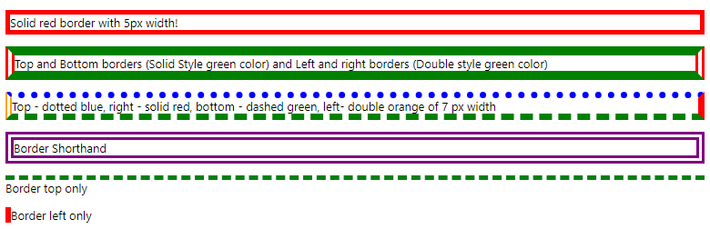

Box Properties
Box properties control the size, spacing, and appearance of HTML elements.
They are part of the CSS Box Model, which consists of:
- Content – the actual text or image inside the box
- Padding – space between content and border
- Border – the edge surrounding the padding
- Margin – space outside the border

Box properties allow you to define:
- How much space an element occupies (using width and height)
- How far it is from other elements (margin)
- The space between content and border (padding)
- Borders and shadows to highlight or style elements (box-shadow)
- How width and height are calculated (box-sizing)
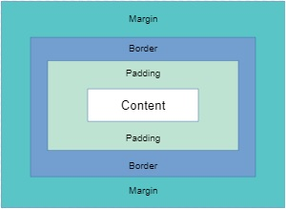

Property | Description | Why to Use | Possible Values / Syntax / Examples
margin | Creates space outside the element (outside border). | To separate elements on the page. | Values:  • auto → browser calculates margin (useful for centering)  • length → px, em, %, negative values allowed  Shorthand examples:  • 4 values → margin: 25px 50px 75px 100px; → top=25px, right=50px, bottom=75px, left=100px  • 3 values → margin: 25px 50px 75px; → top=25px, right/left=50px, bottom=75px  • 2 values → margin: 25px 50px; → top/bottom=25px, right/left=50px  • 1 value → margin: 25px; → all sides=25px
padding | Creates space inside the element (between content & border). | To add inner spacing inside the element. | Values:  • length → px, em, %  Shorthand examples:  • 4 values → padding: 25px 50px 75px 100px; → top=25px, right=50px, bottom=75px, left=100px  • 3 values → padding: 25px 50px 75px; → top=25px, right/left=50px, bottom=75px  • 2 values → padding: 25px 50px; → top/bottom=25px, right/left=50px  • 1 value → padding: 25px; → all sides=25px
width | Specifies the width of an element’s content area. | To control horizontal size of the element. | Values: auto, length (px, em, %),
height | Specifies the height of an element’s content area. | To control vertical size of the element. | Values: auto, length (px, em, %),
box-sizing | Defines how width and height are calculated — whether padding and borders are included. | To control layout behavior when adding padding/borders. | Values:  • content-box (default): width/height exclude padding & border.  • border-box: width/height include padding & border.
box-shadow | Adds shadow effects around an element’s frame. | To add depth, hover effects, or visual highlights. | Syntax: box-shadow: h-offset v-offset blur spread color;  Example: box-shadow: 2px 2px 5px gray;

Example
<head>
<style>
.box1 {
width: 300px; /* width of box */
height: 150px; /* height of box */
margin: 30px auto; /* outer spacing & centered horizontally */
padding: 20px; /* inner spacing */
border: 4px solid teal; /* border around the box */
box-sizing: content-box; /* width/height includes content only */
box-shadow: 5px 5px 15px gray; /* shadow around the box */
background-color: lightyellow;
text-align: center;
}
.box2 {
width: 300px;
height: 150px;
margin: 30px auto;
padding: 20px;
border: 4px solid purple;
box-sizing: border-box; /* width/height includes content + padding + border */
box-shadow: 5px 5px 15px gray;
background-color: lightpink;
text-align: center;
}
</style>
</head>
<body>
<h2>Box Properties Demonstration</h2>
<div class="box1">
Box 1 - box-sizing: content-box<br>
width and height include only content
</div>
<div class="box2">
Box 2 - box-sizing: border-box<br>
width and height include content + padding + border
</div>
</body>
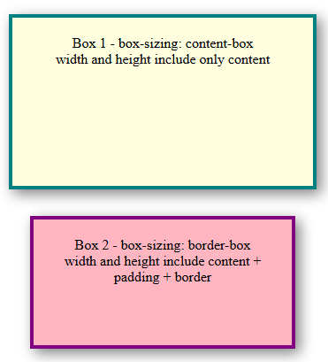

Box-Sizing Comparison
Box 1 – content-box
- Declared size: 300×150 px
- Padding: 20 px, Border: 4 px
- Total width: 300 + 20 + 20 + 4 + 4 = 348 px
- Total height: 150 + 20 + 20 + 4 + 4 = 198 px
➡️ Padding and border are added outside the content.
Box 2 – border-box
- Declared size: 300×150 px
- Padding: 20 px, Border: 4 px
- Content width: 300 − (20 + 20 + 4 + 4) = 252 px
- Content height: 150 − (20 + 20 + 4 + 4) = 102 px
➡️ Padding and border are included within the declared size.
Box | box-sizing | Declared Size | Rendered Size | Notes
Box 1 | content-box | 300×150 px | 348×198 px | Adds padding + border
Box 2 | border-box | 300×150 px | 300×150 px | Includes padding + border

  - CSS background properties
CSS background properties are a set of properties that allow you to control the appearance of the background of HTML elements. This includes color, images, repetition, position, size, attachment, and clipping.
Why use them?
- To enhance the visual design of a webpage.
- To highlight elements with colors or images.
- To control the layout and behavior of background images (repeat, size, position, scroll behavior).
- To create visually appealing effects using shorthand or combined properties.

Property | Description | Syntax | Key Values / Notes
background-color | Sets the background color of an element | background-color: color; | Any valid color (red, #ffc0cb, rgb(255,0,0))
background-image | Sets an image as the background | background-image: url("image.jpg"); | Use image URL;
background-repeat | Controls how background image repeats | background-repeat: repeat; | repeat, repeat-x, repeat-y, no-repeat  default repeats if not specified
background-position | Sets the starting position of a background image | background-position: top; | top, bottom, left, right, center, x% y%
background-size | Specifies the size of the background image | background-size: auto; | auto, cover, contain, width height
background-attachment | Sets whether background scrolls with content | background-attachment: scroll; | scroll, fixed, local
background-clip | Determines how far the background extends | background-clip: border-box; | border-box, padding-box, content-box
background (shorthand) | Combines color, image, repeat, position, size, attachment | background: [color] [image] [repeat] [position] [size] [attachment]; | Example: background: pink url("scenary.jfif") no-repeat top right cover fixed;

background-color
The background-color property specifies the background color of an element.
Example
<html>
<head>
<style>
h1 {background-color: rgb(25, 128, 134);}
div {background-color: #FFC0CB;}
p {background-color: #bcd;}
pre {background-color: aqua;}
</style>
</head>
<body>
<h1>CSS background-color</h1>
<div>
This is a text inside a div element.
<p>This paragraph has its own background color.</p>
We are still in the div element.
<pre>Preformatted text
with its own
background color
</pre>
</div>
</body>
</html>
Output:
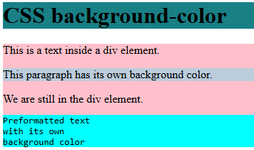

Understanding Of color selection
Format | Example | Full Form / Meaning | Value Range | Key Points
HEX (6 digits) | #ffffff | Hexadecimal RGB value | 00 → ff | Each pair = Red, Green, Blue; common format for web colors
HEX (3 digits) | #fff | Short form of HEX | 0 → f | Shorthand for 6-digit HEX (#fff = #ffffff)
RGB | rgb(255, 255, 255) | Red, Green, Blue | 0 → 255 | Easy to visualize and edit color intensities
RGBA | rgba(255, 0, 0, 0.5) | Red, Green, Blue, Alpha | 0 → 255 (RGB), 0 → 1 (Alpha) | “A” controls transparency (1 = opaque, 0 = fully transparent)

background-image
- Sets the background image for an element
- The background-image property specifies an image to use as the background of an
element.
- By default, the image is repeated so it covers the entire element.
- The background image can also be set for specific elements, like the <p> element.
Note: When using a background image, use an image that does not disturb the text.
Example:
<html>
<head>
<style>
body { background-image: url("scenary.jfif"); }
</style>
</head>
<body>
<h1>BACKGROUND IMAGE</h1>
<p>By default, the image is repeated so it covers the entire element.</p>
</body>
</html>
Output:
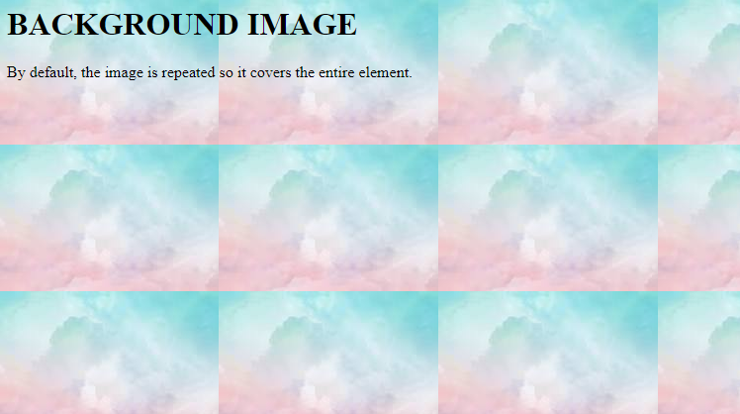

background-repeat
- By default, the background-image property repeats an image both horizontally and vertically.
- Some images should be repeated only horizontally or vertically, or they will look strange.
- To repeat an image vertically, set background-repeat: repeat-y;
- To repeat an image horizontally, set background-repeat: repeat-x;
- To repeat an image only once, set background-repeat: no-repeat;
Example (repeat-x):
<head>
<style>
body {
background-image: url("nature.jfif");
background-repeat: repeat-X;
}
</style>
</head>
<body>
<h1>BACKGROUND IMAGE(REPEAT-X)</h1>
<p>THE IMAGE IS REPEATED HORIZONATLLY</p>
</body>

Output:


Example (repeat-y):
<head>
<style>
body {
background-image: url("scenary.jfif");
background-repeat: repeat-y;
}
</style>
</head>
<body>
<h1>BACKGROUND IMAGE(REPEAT-Y)</h1>
<p>THE IMAGE IS REPEATED VERTICALLY</p>
</body>
Output:
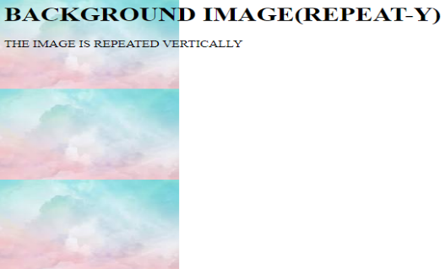
Example (no-repeat)
<head>
<style>
body {
background-image: url("scenary.jfif");
background-repeat: no-repeat;
}
</style>
</head>
<body>
<h1>BACKGROUND IMAGE(no-repeat)</h1>
<p>THE IMAGE IS REPEATED ONLY ONCE</p>
</body>
Output:
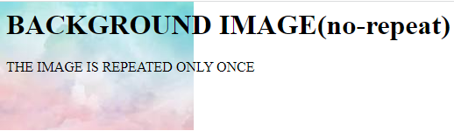

background-clip
background-clip defines how far the background (color or image) extends within an element’s box whether it goes under the border, stops at padding, or only fills the content area.
Value | Description | Background Covers | Visual Effect
border-box (default) | Background extends under the border | Border + Padding + Content | Background color/image is visible behind the border
padding-box | Background is painted only inside the padding area | Padding + Content | Background stops before the border
content-box | Background is painted only behind the content | Content only | Background ignores border and padding (appears smaller)
Example:

box1 {
width: 400px;
height: 200px;
padding: 50px;
background-size:cover;
background-image: url("nature.jpg");
border: 20px dotted;
background-color: rgb(85, 75, 77); /* background color */
background-clip:border-box;
text-align: center;
font-size: 18px;
}
<div class="box1">
This box demonstrates <br>
background-color + background-clip + border + padding
</div>

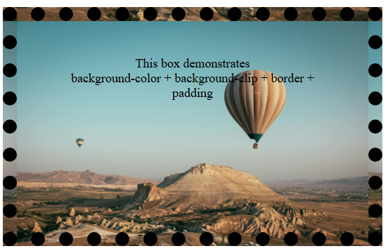

If value is “content-box” then below will be the possible output.

Background ignores border and padding (appears smaller)

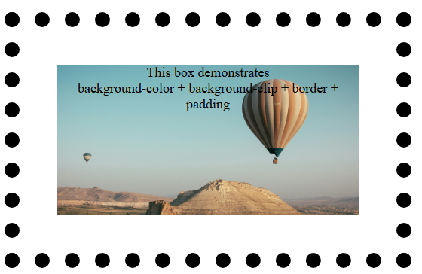

If value is “padding-box” then below will be the possible output.
Background stops before the border

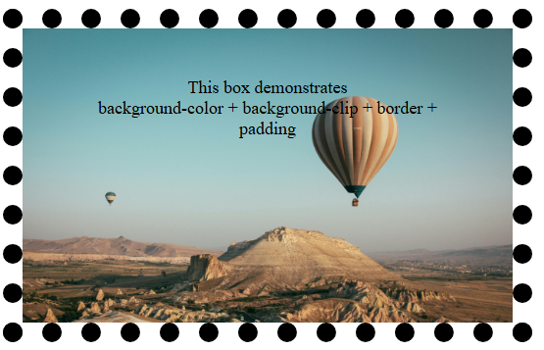

Background-size
- background-size defines how a background image fits or scales inside an element.
- It controls whether the image repeats, stretches, or maintains proportions — very useful for responsive design and banners.
Value | Description | When to Use | Example
auto | Default — image keeps its original size | When you don’t want to resize the image | background-size: auto;
cover | Scales image to completely cover the area (cropping if needed) | For full-screen backgrounds or banners | background-size: cover;
contain | Scales image to fit inside the box without cropping | When you want the full image visible | background-size: contain;
100% 100% | Stretches image to fill width and height | When exact fit is needed | background-size: 100% 100%;
width height | Manually set image size | When you want precise control | background-size: 200px 100px;

Example
<head>
<title>CSS Background Properties Demo</title>
<style>
.box1 {
width: 600px;
height: 400px;
background-size:auto;
background-image: url("nature.jpg");
background-color: black; /* background color */
}
</style>
</head>
<body>
<div class="box1">
This box demonstrates <br> background-size property
</div></body>



If value is “cover” possible output is as below.

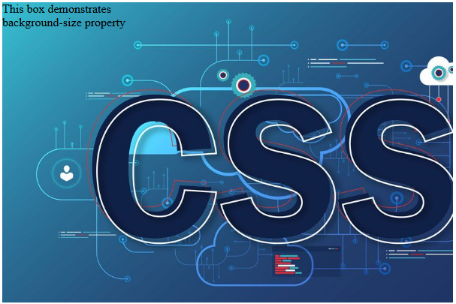

If value is “contain” possible output is as below.

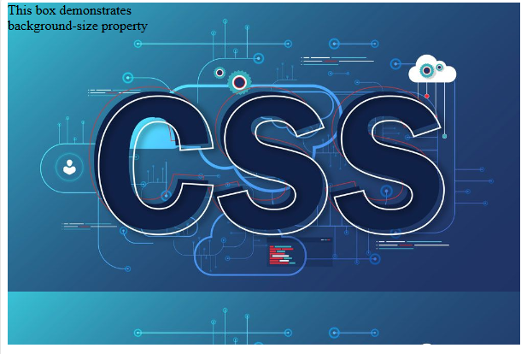

If value is specified as “width height” possible output is as below. Here value applied is “300px 200px”. Default value for background-repeat is “repeat”

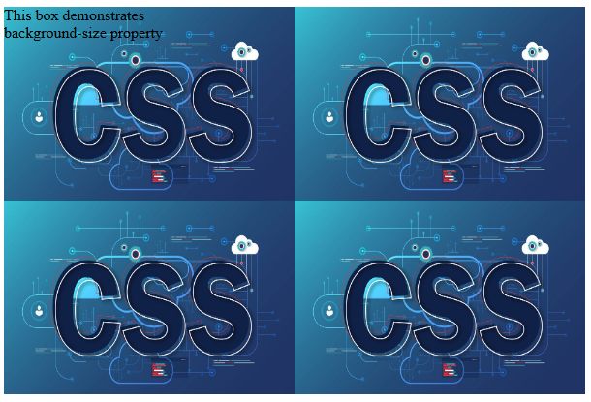

background-attachment

It defines whether the background image scrolls with the page or stays fixed in place.
This helps create visual effects like parallax scrolling or fixed banners.
Value | Description | Effect / Behavior | Common Use
scroll (default) | Background image moves with the page when you scroll | Image scrolls normally along with the content | Default for most elements
fixed | Background image stays fixed in the same place while the content scrolls | Creates a “parallax” or fixed-banner effect | Used in headers, full-screen backgrounds

background-position
The background-position property defines where the background image starts inside an element.
By default, a background image starts at the top-left corner (0% 0%).
But you can move or align it anywhere center, bottom, right etc.
- Control image placement (not always top-left)
- Align the image with text or layout
- Show a specific part of a large image (like a logo or cropped photo)
- Create design balance (especially in banners or cards)
- Combine with background-size for perfect image alignment
Value | Description | Effect
left top | Default | Image starts at top-left corner
Center | Centers both horizontally and vertically | Image stays in the middle
top / bottom / left / right / center | Keywords for alignment | Combine as top center, bottom right, etc.

Example
<head>
<title>Background Position & Attachment Example</title>
<style>
body {
height: 1000px; /* just to make scrolling visible */
background-color: lightblue; /* fallback color */
background-image: url("nature.jpg");
background-repeat: no-repeat;
/* controlling where the image appears */
background-position: bottom right ; /* places image at bottom-right corner */
/* controlling how it behaves during scroll */
background-attachment: fixed; /* image stays fixed while content scrolls */
/* scaling the image */
background-size: cover;
}
</style>
</head>
<body>
<div>
<h1>CSS background-position + background-attachment</h1>
<p>
Scroll this page and notice how the background image stays in the same position
on the screen because <b>background-attachment: fixed;</b> keeps it fixed, while
<b>background-position: bottom right;</b> keeps the image anchored to the bottom-right corner.
</p>
<p>
Change <code>background-attachment</code> to <code>scroll</code> and reload —
you’ll see the image moves with the page instead.
</p>
</div>
</body>

Using Shorthand for Combined Effects
- Effect: Apply multiple properties at once for compact code.
- Shorthand Properties Used Together: background-color, background-image, background-repeat, background-position, background-size, background-attachment
Syntax:
background: [color] [image] [repeat] [position] / [size] [attachment];

Example:
background: lightpink url("scenary.jfif") no-repeat top right / cover fixed;

Part | Meaning
lightpink | background-color
url("scenary.jfif") | background-image
no-repeat | background-repeat
top right | background-position
/ cover | background-size (the / separates it from position)
fixed | background-attachment

Note:
/ is mandatory only when you specify both position and size. If you specify just one of them, no / is needed.

Pseudo Class And Pseudo Element

What are they and their purpose?
- Pseudo-class: Used to style elements based on their state or position. Example: hover, focus, visited link.
- Pseudo-element: Used to style specific parts of an element or insert content. Example: first letter, first line, before/after content.
- Purpose: Both allow you to apply special styles without adding extra HTML, making your CSS more powerful and dynamic.
Type | Pseudo | Description | Syntax | Example
Pseudo-class | :link | Targets unvisited links | a:link { color: red; } | Unvisited links appear red
Pseudo-class | :visited | Targets visited links | a:visited { color: green; } | Visited links appear green
Pseudo-class | :hover | Applies style when mouse hovers | div:hover { background-color: red; } | Box changes color on hover
Pseudo-class | :active | Applies style while element is clicked | div:active { background-color: orange; } | Box changes color while clicking
Pseudo-class | :focus | Applies style to focused input | input:focus { background-color: lightgreen; } | Input background changes when focused
Pseudo-class | :nth-child(n) | Selects the nth child of parent | li:nth-child(2) { color: orange; } | Second <li> element is orange
Pseudo-class | :not(selector) | Select elements not matching a selector | p:not(.special) { color: black; } | All <p> except class .special are black
Pseudo-element | ::first-line | Styles the first line of a block element | p::first-line { font-weight: bold; } | First line of paragraph is bold
Pseudo-element | ::first-letter | Styles the first letter of a block element | p::first-letter { font-size: 50px; } | First letter of paragraph is large
Pseudo-element | ::before | Inserts content before element | p::before { content: "Note: "; color: red; } | Adds “Note:” before paragraph
Pseudo-element | ::after | Inserts content after element | p::after { content: "."; color: red; } | Adds “.” after paragraph
Pseudo-element | ::marker | Styles list item marker | li::marker { color: red; font-size: 20px; } | Bullets or numbers appear red
Pseudo-element | ::selection | Styles text selected by user | ::selection { background: blue; color: white; } | Highlighted text appears white on blue

Pseudo classes

- A Pseudo class in CSS is used to define the special state of an element.
- It can be combined with a CSS selector to add an effect to existing elements based on their states.
- For Example, changing the style of an element when the user hovers over it, or when a link is visited. All of these can be done using Pseudo Classes in CSS.
Note that pseudo-class names are not case-sensitive.

Pseudo-class | What It Does
:hover | Changes color when mouse hovers
:active | Changes color when clicked
:focus | Highlights input field when clicked
:link / :visited | Colors for unvisited/visited links
:nth-child(2) | Targets the 2nd list item
:not(.special) | Styles all list items except .special

Syntax:
selector : pseudo-class{
property: value;
}
Example
<html>
<head>
<style>
/* unvisited link */
a:link {
color: red;
}
/* visited link */
a:visited {
color: green;
}
/* mouse over link */
a:hover {
color: pink;
}
/* selected link */
a:active {
color: blue;
}
</style>
</head>
<body>
<h2>Styling a link depending on state</h2>
<p><b><a href="https://www.google.com" target="_blank">This is a link</a></b></p>
</body>
</html>

a:hover MUST come after a:link and a:visited in the CSS definition in order to be effective.
a:active MUST come after a:hover in the CSS definition in order to be effective.

Output:
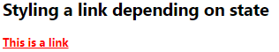Link

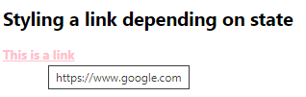Hover

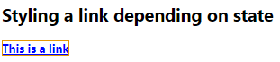Active

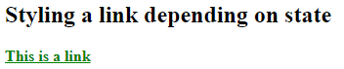Visited

Example
Design a webpage that includes:
- A button that changes its color when hovered over and when clicked.
- A text input field that changes its background color when it gains focus.
- A checkbox that changes the color of its label and makes the label bold when checked.
- An unordered list where:
  - The second list item is styled differently, with red text color and bold font.
  - One of the list items has a class named “special”, and all other list items (except the one with this class) have an aqua background and italic font style.
<head><style>
/* ====== BUTTON STATES ====== */
button {
background-color: lightblue;
border: none;
padding: 10px 20px;
font-size: 16px;
margin: 5px;
}
button:hover {
background-color: navy;
color: white;
}
button:active {
background-color: orange;
}
/* ====== INPUT STATES ====== */
input:focus {
background-color: lightgreen;
border: 2px solid green;
}
/* ====== LIST ITEMS ====== */
ul li:nth-child(2) {
color: red;
font-weight: bold;
}
ul li:not(.special) {
font-style: italic;
background-color: aqua;
}
</style></head>
<body>
<!-- Buttons -->
<button>Hover or Click Me</button>
<!-- Input fields -->
<label for="name">Name:</label>
<input type="text" id="name" placeholder="Click to focus"><br><br>
<!-- List Example -->
<ul>
<li>First item</li>
<li>Second item (nth-child)</li>
<li class="special">Special item (not affected)</li>
<li>Fourth item</li>
</ul>
</body>

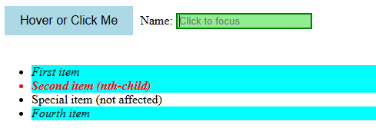
Pseudo Elements
Pseudo-element | Description | Syntax | Example | Result / Effect
::first-line | Styles the first line of a block-level element. | p::first-line { property: value; } | p::first-line { color: red; font-weight: bold; } | First line of the paragraph appears red and bold.
::first-letter | Styles the first letter of a block-level element. | p::first-letter { property: value; } | p::first-letter { font-size: 50px; color: red; } | First letter of the paragraph becomes large and red.
::before | Inserts content before an element’s actual content. | selector::before { content: "..."; } | p::before { content: "Note: "; color: red; } | Adds “Note:” before each paragraph.
::after | Inserts content after an element’s actual content. | selector::after { content: "..."; } | p::after { content: " ✔"; color: green; } | Adds a green checkmark after the paragraph.
::marker | Styles the marker (bullet or number) of list items. | li::marker { property: value; } | li::marker { color: red; font-size: 20px; } | List bullets or numbers appear red and large.
::selection | Styles the highlighted text selected by the user. | ::selection { property: value; } | ::selection { background: blueviolet; color: white; } | Selected text appears white on a blue-violet background.
A CSS pseudo-element is used to style specified parts of an element. It can be used to:
- A pseudo-element can be used to style the first letter or the first line of an element.
- The pseudo-elements can also be used to insert the content after or before an element.
Syntax
selector::pseudo-element {
property: value;
}
We have used the double colon notation (::pseudo-element) in the syntax.
In CSS3, the double colon replaced the single colon notation for pseudo-elements. It was an attempt from W3C to differentiate between the pseudo-elements and pseudo-classes. So, it is recommended to use double colon notation (::pseudo-element) instead of using single-colon notation (:).
<head>
<style>
/* ===== FIRST LINE & FIRST LETTER ===== */
p::first-line {
color: red;
font-weight: bold;
}
p::first-letter {
font-size: 50px;
color: blue;
text-decoration: underline;
}
/* ===== BEFORE & AFTER ===== */
p::before {
content: " Note: ";
color: green;
}
p::after {
content: "😊";
}
/* ===== MARKER ===== */
ul li::marker {
color: purple;
font-size: 40px;
}
/* ===== SELECTION ===== */
::selection {
background-color: yellow;
color: red;
}
</style></head>
<body>
<h2>CSS Pseudo-elements Example</h2>
<p>
This is a paragraph demonstrating CSS pseudo-elements. The first letter and first line are styled differently, and extra content is added before and after the text.
</p>
<ul>
<li>HTML</li>
<li>CSS</li>
<li>JavaScript</li>
</ul>
</body>
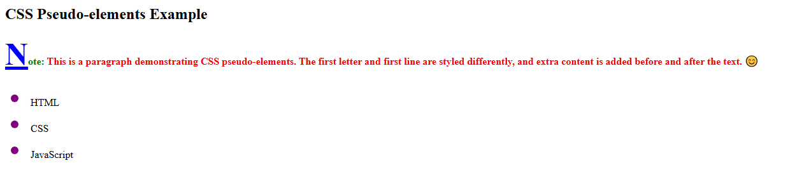

Insert Emoji (Smiley) Using Keyboard in VS CODE
Windows key + . (period)
or
Windows key + ; (semicolon)

Display Property
The display property is one of the most important CSS properties because it controls how elements are displayed and positioned on a web page.
It tells the browser how an element should behave in the document layout whether it should appear inline, as a block, as a flexible box, or be hidden entirely.
Display Type | Description | Behavior / Use Case | Visual Behavior
inline | Displays elements in a line, without starting on a new line. | Does not accept width/height. Common for <span>, <a>, <strong>. | Elements sit side by side in a single line.
block | Displays element as a block, starting on a new line. | Takes full width available and allows width/height to be set. | Each element appears on a new line.
inline-block | Combines features of inline and block. | Appears inline, but allows width and height. | Boxes are side by side, but size-controllable.
none | Hides the element completely (removed from layout). | Element takes no space on the page. | The element is invisible and does not occupy space.

Example:
<head>
<style>
.box {
background-color: lightblue;
border: 2px solid navy;
padding: 10px;
margin: 5px;
text-align: center;
}
/* INLINE - appear side by side */
.inline div {
display: inline;
background-color: yellow;
border: 1px solid orange;
padding: 5px;
}
/* BLOCK - start on a new line */
.block span {
display: block;
background-color: lightcoral;
border: 1px solid red;
color: white;
padding: 10px;
margin-bottom: 5px;
}
/* INLINE-BLOCK - side by side + size controllable */
.inline-block div {
display: inline-block;
background-color: lightgreen;
border: 2px solid green;
width: 120px;
height: 60px;
line-height: 60px;
margin: 5px;
}
/* NONE - hidden element */
.none p {
display: none;
}
</style>
</head>
<body>
<h2>CSS Display Property Example</h2>
<!-- INLINE -->
<h3>display: inline</h3>
<div class="inline box">
<div>Inline 1</div>
<div>Inline 2</div>
<div>Inline 3</div>
</div>
<p> These elements appear <strong>side by side</strong>; width and height cannot be set individually.</p>
<!-- BLOCK -->
<h3>display: block</h3>
<div class="block box">
<span>Block 1</span>
<span>Block 2</span>
<span>Block 3</span>
</div>
<p> Each element starts on a <strong>new line</strong> and takes full width.</p>
<!-- INLINE-BLOCK -->
<h3>display: inline-block</h3>
<div class="inline-block box">
<div>Box 1</div>
<div>Box 2</div>
<div>Box 3</div>
</div>
<p> These elements sit <strong>side by side</strong> but allow <strong>width and height</strong> adjustments.</p>
<!-- NONE -->
<h3>display: none</h3>
<div class="none box">
<p>This text is hidden using display:none;</p>
</div>
<p> The hidden text does <strong>not take up any space</strong> on the page.</p>
</body>
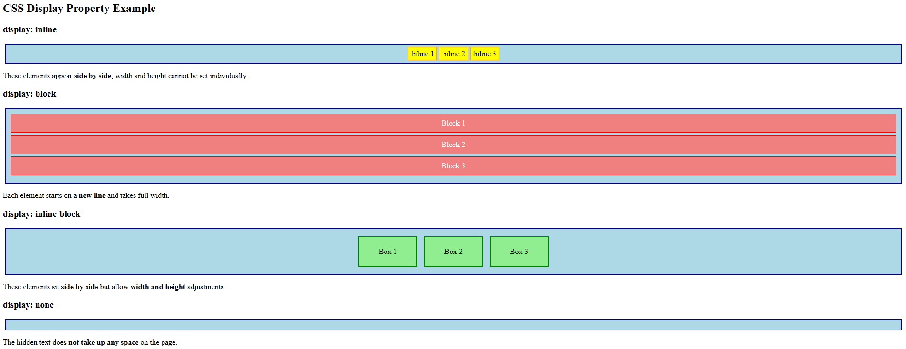

CSS Positioning Properties
Property | Description | Possible Values | Default Value | Syntax / Example
position | Defines how an element is positioned in the document. | static, relative, absolute, fixed, sticky | static | position: absolute;
top | Distance between element and top edge of container. | Any CSS length (px, %, auto) | auto | top: 20px;
right | Distance between element and right edge of container. | Any CSS length (px, %, auto) | auto | right: 10px;
bottom | Distance between element and bottom edge of container. | Any CSS length (px, %, auto) | auto | bottom: 15px;
left | Distance between element and left edge of container. | Any CSS length (px, %, auto) | auto | left: 30px;
z-index | Controls stack order of overlapping elements. | Integer (auto, positive or negative values) | auto | z-index: 2; (Higher = on top)

- static: Default, element follows normal document flow.
- relative: Moved relative to its normal position.
- absolute: Positioned relative to the nearest positioned ancestor.
- fixed: Stays fixed in place even when scrolling.
- z-index: Controls which element appears on top of others.

Example to understand position

<html>
<head>
<style>
.container{
margin-top: 50px;
height: 800px;
border: 1px solid red;
position: relative;
}
.container1{
margin-top: 30px;
height: 1000px;
border: 2px solid black;
}
.test {
margin-left: 20px;
height: 100px;
width : 100px;
text-align: center;
font-size:30px;
}
#test1{
background-color: aqua;
}
#test2{
background-color: rgb(76, 0, 255);
position: relative;
top: 50px;
left:40px;
z-index: 1;
}
#test3{
background-color: rgb(255, 0, 140);
position: absolute;
top: 100px;
right: 0px;
}
#test4{
background-color: rgb(208, 255, 0);
position: fixed;
top: 50px;
right: 0;
}
#test5{
background-color: rgb(255, 0, 0);
position: sticky;
top: 0px;
}
</style>
</head>
<body>
<div class="container">
<div class="test" id="test1">1</div>
<div class="test" id="test2">2</div>
<div class="test" id="test3">3</div>
<div class="test" id="test4">4</div>
<div class="test" id="test5">5</div>
</div>
<div class="container1"></div>
</body>
</html>

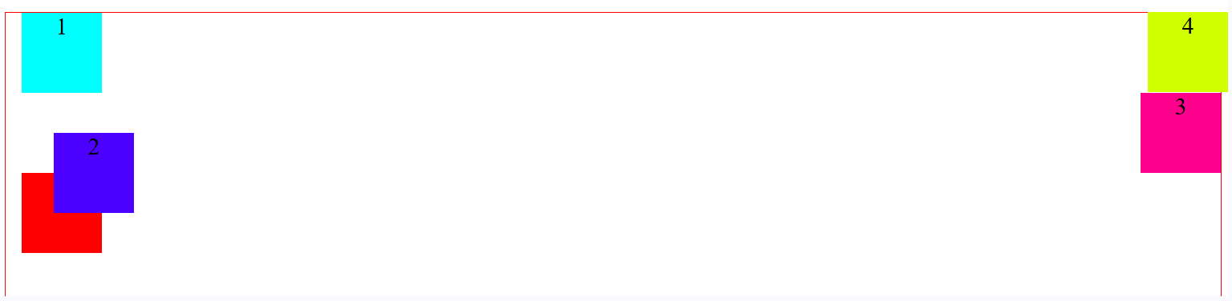

Selector | Position Type | Behavior / Explanation
#test1 | static (default) | No positioning applied follows normal document flow.
#test2 | relative | Moved 50px down and 40px right from its normal position. The original space is still reserved.
#test3 | absolute | Placed 100px from top and 0px from right of the nearest positioned ancestor (.container has position: relative, so that’s the reference).
#test4 | fixed | Positioned 50px from top and right of the viewport, stays fixed even when scrolling.
#test5 | sticky | Acts like a normal element until the page is scrolled then it sticks to the top (0px) of its container.

Flexbox property
- Flexbox (short for Flexible Box Layout) is a modern CSS layout model that provides an efficient way to align, distribute, and space items inside a container even when their size is unknown or dynamic.
- It’s designed to make it easier to create responsive layouts, where elements adjust automatically to different screen sizes and available space.
Property | Description | Possible Values | Syntax / Example
display: flex | Defines a flex container to arrange items flexibly. | flex, inline-flex | div { display: flex; }
flex-direction | Defines the direction of flex items. | row (default), row-reverse, column, column-reverse | flex-direction: row;
justify-content | Aligns items horizontally (along the main axis). | flex-start, flex-end, center, space-between, space-around, space-evenly | justify-content: space-between;
align-items | Aligns items vertically (along the cross axis). | stretch (default), flex-start, flex-end, center | align-items: center;
flex-wrap | Determines whether flex items wrap onto multiple lines. | nowrap (default), wrap, wrap-reverse | flex-wrap: wrap;
gap | Defines the space between flex items. | Any CSS length unit (px, em, %) | gap: 15px;
order | Specifies the display order of flex items. | Integer values (0 default, can be positive or negative) | order: 2;
flex (shorthand) | Sets how an item grows, shrinks, and defines its base size. | flex: grow shrink basis; e.g., flex: 1 0 100px; | flex: 1; or flex: 1 0 200px;
Flex Example
<head>
<style>
.container {
display: flex; /* Creates a flex container. Change values and check effects */
flex-direction: row; /* Arranges items in a row (default). Change values and check effects */
justify-content: space-between; /* Spaces items horizontally. Change values and check effects */
align-items: center; /* Aligns items vertically in the center. Change values and check effects */
flex-wrap: wrap; /* Wraps items to next line if space runs out */
gap: 15px; /* Adds space between items */
background-color: lightgray;
padding: 15px;
}
.item {
background-color: steelblue;
color: white;
padding: 20px;
text-align: center;
border-radius: 5px;
width: 200px;
}
.item:nth-child(2) {
order: 1; /* This will move the item to appear after others. Change values and check effects(POSITIVE,NEGATIVE,0) */
/* flex: 1 1 100px; */ /* Remove comments from this line to check effect. flex-grow: 1, flex-shrink: 1, flex-basis: 100px */
background-color: orange;
}
</style>
</head>
<body>
<div class="container">
<div class="item">Item 1</div>
<div class="item">Item 2 (Order 1)</div>
<div class="item">Item 3</div>
</div>
</body>
Property | Description | In This Example
display: flex | Turns the container into a flexbox container. | .container becomes a flex container, and its child .item elements become flex items.
flex-direction: row | Arranges flex items horizontally (left to right). | All .item boxes appear side by side.
justify-content: space-between | Distributes items evenly with space between them. | The first and last item stick to edges; middle items get even gaps.
align-items: center | Aligns items vertically along the cross-axis. | Centers items vertically within the container’s height.
flex-wrap: wrap | Allows items to wrap to a new line if there’s not enough space. | If you resize the browser, items will move to the next row.
gap: 15px | Adds space between flex items. | Creates uniform spacing (15px) between all .items.
order | Defines the visual order of items (default = 0). | order: 1 makes Item 2 appear after Items 1 and 3.
flex: 1 1 100px | Shorthand for flex-grow, flex-shrink, and flex-basis. | Item 2 starts at 100px wide, can grow and shrink with available space.

Normal Flow: Item 1 | Item 2 | Item 3
After order: 1 on Item 2:It moves after the other two → Item 1 | Item 3 | Item 2
Resize the browser window:Item 2 (with flex: 1 1 100px) will stretch or shrink smoothly as the container grows or shrinks.

Grid Layout Properties
- CSS Grid Layout is a two-dimensional layout system. It allows you to arrange content in rows and columns easily.
- It’s perfect for designing web page structures, galleries, dashboards, or complex layouts without relying on floats or flexbox hacks.
Property | Description | Possible Values | Default Value | Syntax / Example
grid-template-columns | Defines the number and width of columns in a grid layout. | Fixed units (px, em, %) | none | grid-template-columns: 200px 1fr 2fr;  The fr unit means “fraction of the available space.”
grid-template-rows | Defines the number and height of rows in a grid layout. | Fixed units (px, em, %), | none | grid-template-rows: 100px auto 100px;
gap (grid-gap) | Defines the space between rows and columns. | Any CSS length (px, em, %) | 0 | gap: 10px; or gap: 20px 40px;
grid-column | Specifies the horizontal position of an item within the grid columns (start / end lines). | <start-line> / <end-line> | auto | grid-column: 1 / 3; (spans across 2 columns)
grid-row | Specifies the vertical position of an item within the grid rows (start / end lines). | <start-line> / <end-line> | auto | grid-row: 1 / 2; (spans across 1 row)
Example:
<head>
<style>
/* ===== Example 1: Fixed + Flexible Columns ===== */
.grid1 {
display: grid;
grid-template-columns: 200px 1fr 2fr; /* 3 columns: fixed + flexible */
grid-template-rows: 1fr 2fr; /* 2 flexible rows (1:2 ratio) */
gap: 10px;
background-color: lightgray;
padding: 10px;
margin-bottom: 40px;
}
/* ===== Example 2: Equal Columns ===== */
.grid2 {
display: grid;
grid-template-columns: repeat(4, 1fr); /* 4 equal columns */
grid-template-rows: 100px;
height:150px;
gap: 10px;
background-color: lightblue;
padding: 10px;
}
.item {
background-color: steelblue;
color: white;
text-align: center;
padding: 20px;
border-radius: 10px;
font-size: 18px;
}
</style>
</head>
<body>
<div class="grid1">
<div class="item">200px (Fixed)</div>
<div class="item">1fr (Flexible)</div>
<div class="item">2fr (Twice as Wide)</div>
</div>
<div class="grid2">
<div class="item">Item 1</div>
<div class="item">Item 2</div>
<div class="item">Item 3</div>
<div class="item">Item 4</div>
</div>
</body>
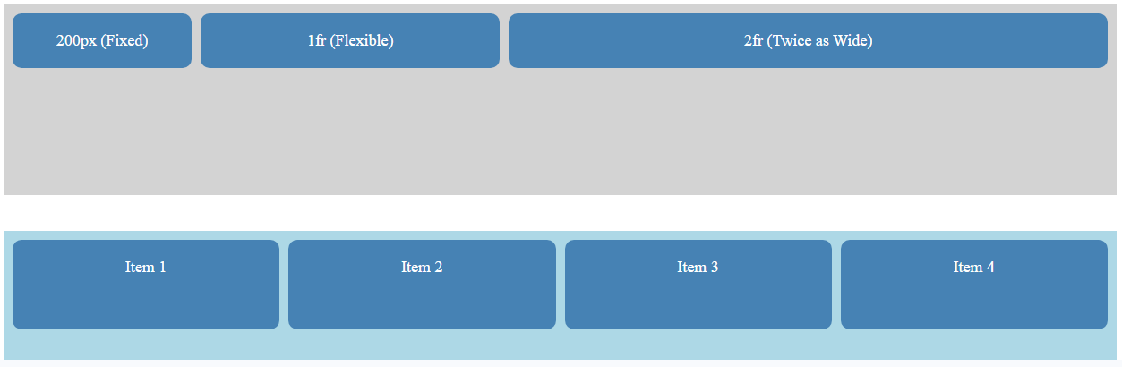

Google Fonts

Why Use Google Fonts?
- Variety of Fonts – Access hundreds of high-quality, free fonts beyond standard system fonts.
- Cross-Browser & Cross-Device – Fonts are hosted online, so they render consistently across browsers and devices.
- Performance Optimized – Google Fonts servers are fast and optimized for web use.
- Easy to Use – Simple embed methods (<link> or @import).
- Customizable Weights & Styles – Choose different weights (400, 600, 700) and styles (italic, normal).

How to Embed Google Fonts

Method 1: Using <link> tag (Recommended)
- Go to Google Fonts.
- Search and select your desired font (e.g., Pacifico).
- Choose the styles/weights you need (e.g., 400).
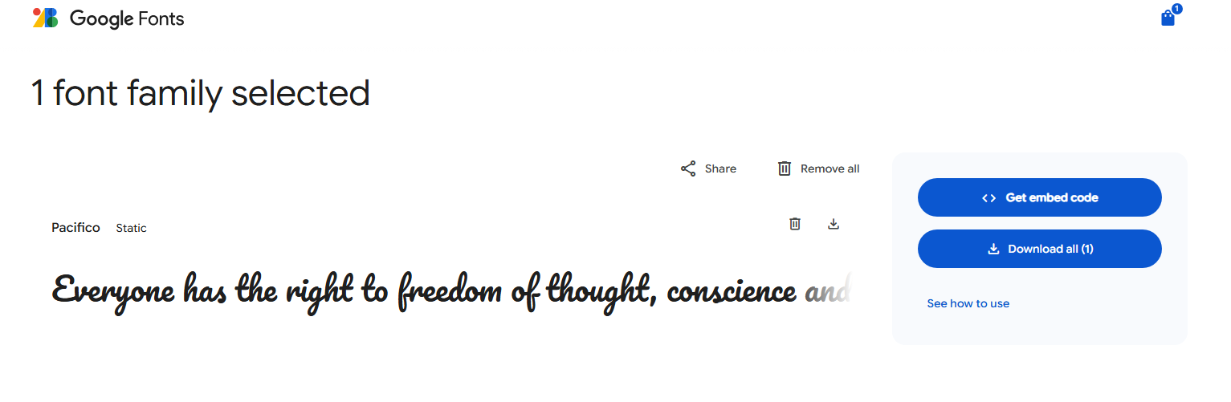
- Copy the <link> tag under Embed section:
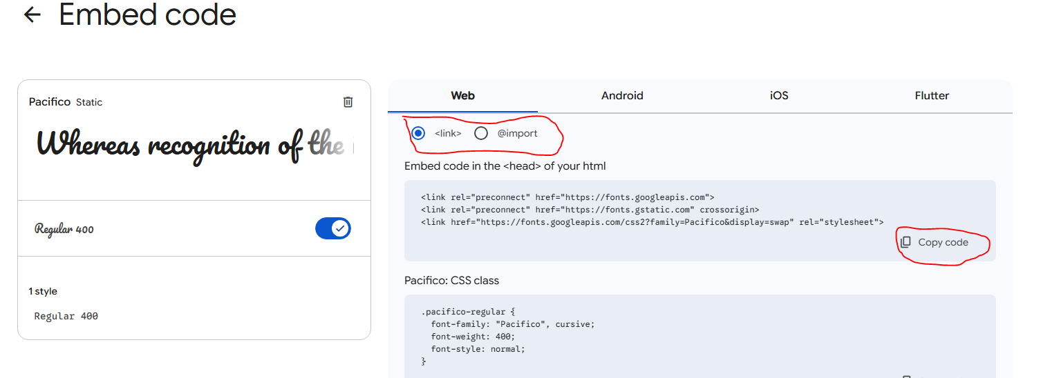
<link href="https://fonts.googleapis.com/css2?family=Pacifico&display=swap" rel="stylesheet">
- Paste it inside the <head> of your HTML file.
- Apply the font in CSS:
body {
font-family: "Pacifico";
}

Method 2: Using @import in CSS
- Go to Google Fonts and select your font.
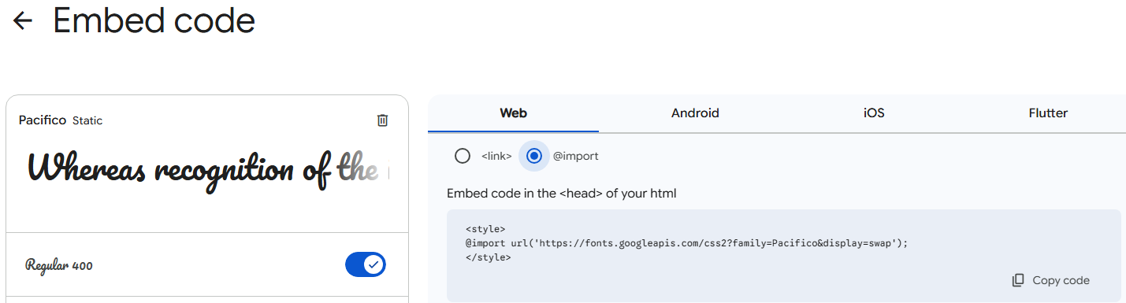
- Copy the @import code:
@import url('https://fonts.googleapis.com/css2?family=Pacifico&display=swap');
- Paste it at the top of your CSS file, before other CSS rules.
- Use the font in CSS:
body { font-family: "Pacifico"; }

Example:
font_example.html
<head>
<link href="https://fonts.googleapis.com/css2?family=Pacifico&display=swap" rel="stylesheet">
<link rel="stylesheet" href="style.css">
<style>
h1{
font-family: "Pacifico";
font-weight: 400;
font-style: normal;
}
</style>
</head>
<body>
<h1>google font Using link</h1>
<h3>Google font using import</h3>
</body>

style.css
@import url('https://fonts.googleapis.com/css2?family=Pacifico&display=swap');
h3{
font-family: "Pacifico";
color: blue;
font-size:30px;
}



